

|  |
| --- |
| Sport Analysis-PSL |
|  |
| August 24  Group G: Neeta Choudhry Naveera Kamal Noor ul ain |



Table of Contents

# INTRODUCTION

# PROJECT SCOPE:

# ER- DAIGRAM:

# APPROACH

# DATA EXPLORATION:

# DASHBOARD VISUALS:

# RECOMMENDATIONS:

## 

INTRODUCTION:

Pakistanis have a passion for cricket, and the Pakistan Super League (PSL) has grown to be an important fixture on the nation's cricket calendar. The "Sport Analysis- PSL 2016-2022 Data Analysis" project seeks to thoroughly analyze the PSL competition data from 2016 to 2022 in order to glean important trends, insights, and patterns. The goal of this project is to provide a thorough study that benefits teams, players, fans, and stakeholders by utilizing data analytics and artificial intelligence.

PROBLEM STATEMENT:

The Sport Analysis for PSL seeks to address the challenge of extracting meaningful insights from the vast array of data generated by the tournament. By utilizing data analytics, the solution aims to provide comprehensive player performance evaluation, strategic decision support for teams, and enhanced fan engagement through interactive visualizations, recognition of historical patterns, predictive modeling, and real-time analysis during matches. Ultimately, the goal is to transform raw data into actionable recommendations that enhance team strategies, player performance, and overall fan experience in the Pakistan Super League, ushering in a new era of data-driven cricket analysis.

Stakeholders:

For PSL data analysis, the stake holders could include:

Cricket Teams: The teams participating in the PSL would have a significant stake in data analysis. They would want to analyze player performance, team strategies, opposition analysis, and more to make informed decisions.

Coaches and Management: Coaches and team management would use data analysis to understand player performance, strengths, weaknesses, and to devise strategies for matches.

Players: Players themselves might be interested in analyzing their own performance data to improve their skills and identify areas for growth.

League Organizers: The organizers of the PSL might use data analysis for various purposes including improving the league's format, marketing decisions, scheduling, and more.

Sponsors and Advertisers: Companies sponsoring or advertising during the PSL might be interested in data analysis to understand the viewership demographics, engagement levels, and the effectiveness of their campaigns.

Broadcasters: Organizations broadcasting the PSL matches could use data analysis to enhance the viewing experience, identify key moments, and tailor their coverage.

Fans: Fans might also engage in data analysis to predict match outcomes, analyze player statistics, and more.

Media and Analysts: Media outlets and cricket analysts might use data analysis to provide insights, predictions, and commentary around PSL matches

OBJECTIVE:

* Comprehensive Data Analysis:

Perform in-depth analysis of PSL data from 2016 to 2022 to extract insights and trends.

* Player Performance Evaluation:

Evaluate batting, bowling, and all-round player performance across seasons.

* Team Dynamics Analysis:

Analyze team performance metrics, including win-loss ratios and net run rates.

* Venue Impact Assessment:

Determine favorable venues for batting and bowling, accounting for seasonal variations.

* Seasonal Trends Identification:

Identify trends and patterns in player and team performance across different seasons.

* Visualizations Creation:

Develop visually appealing charts and graphs to present data insights effectively.

* Strategic Recommendations:

Provide actionable recommendations for teams, players, and organizers to improve strategies.

PROJECT SCOPE:

* Perform extensive data analysis on Pakistan Super League (PSL) data spanning from 2016 to 2022.
* Focus on extracting actionable insights and conducting in-depth analysis across different facets of the tournament.
* Analyze and evaluate player performances, team strategies, and overall tournament dynamics.
* Investigate the impact of different venues on match outcomes, batting, and bowling performances.
* Examine trends and patterns over the years to identify changes in player and team strategies.
* Provide a comprehensive report that encapsulates the findings and insights derived from the analysis.
* Empower decision-making by offering data-driven insights that contribute to strategic planning.
* Offer a deeper understanding of the game by highlighting key statistics and correlations.
* Explore the relationships between player performance, team strategies, and match outcomes.
* The project is limited to PSL data from 2016 to 2022, focusing on its specific timeframe.
* The analysis aims to uncover not only historical trends but also provide actionable insights for future tournaments.

ER-DAIGRAM: 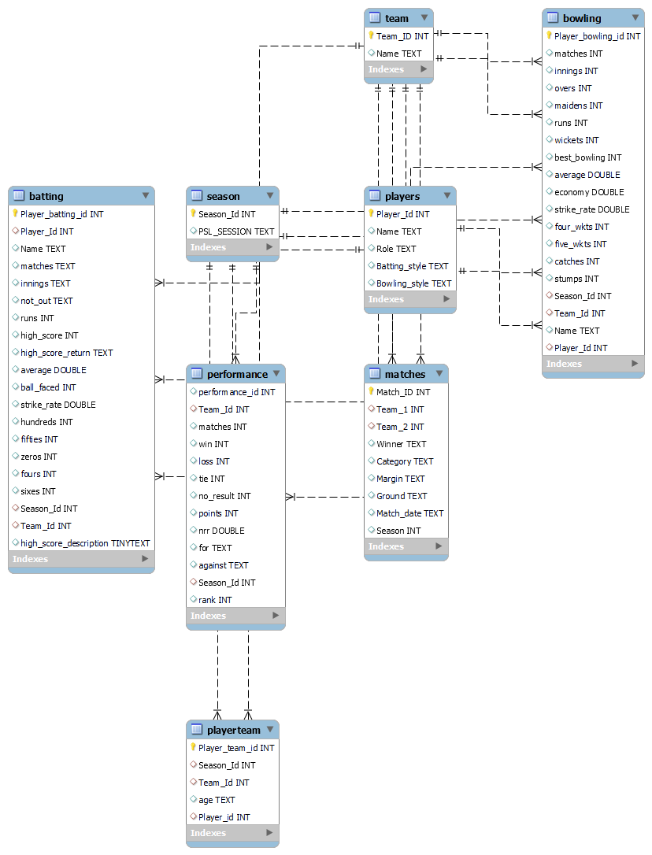

APPROACH:

Data Collection:

Gather PSL data (2016-2022) including match scores, player stats, team info, and venue details from kaggle website.

<https://www.kaggle.com/datasets/ibadkhanml/psl-matches-2016-to-2022?select=matches.csv>

Data Cleaning:

* Clean data to remove inconsistencies, missing values, special characters and errors :

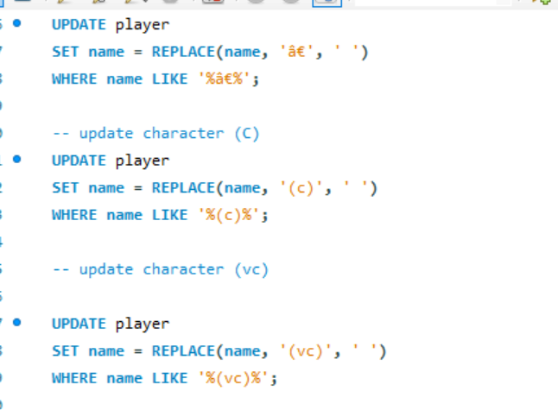

* Rectify incorrect age data types in the Player Team table, affecting 815 rows, through SQL adjustments to ensure accurate age representation.

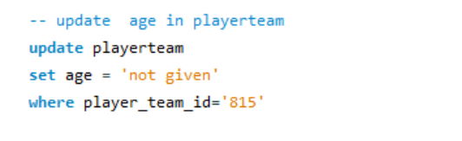

* Complete missing information within the Player table, specifically filling in fields like role, batting style, and bowling style to enhance player profiles comprehensively.
* Standardize data in the Batting and Bowling tables by introducing hyphens as placeholders for rows lacking information, promoting consistency across the dataset.

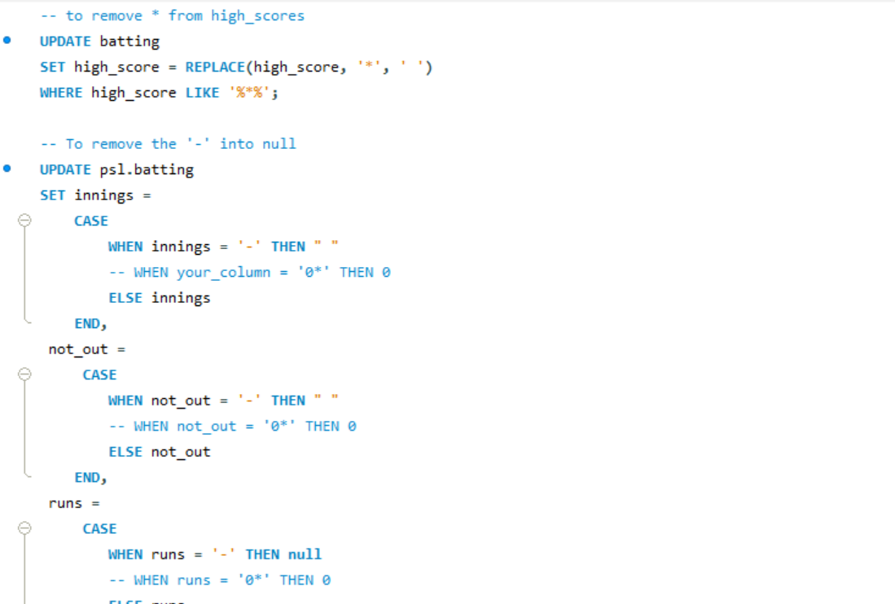

* Eliminate duplicate entries of player names from the Players table to ensure accurate and non-redundant player records.

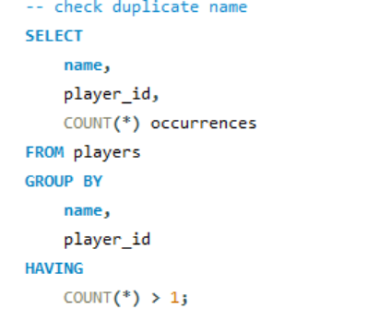

Descriptive Analysis:

* Use basic stats to understand variables like runs, wickets, averages, and strike rates.
* Identify outliers and trends.

Player Performance:

* Calculate batting/bowling averages, strike rates, and other metrics.
* Highlight consistent high performers and notable achievements.

Team Analysis:

* Group data by teams and seasons.
* Analyze team performance trends, win-loss ratios, net run rates, and average scores.

Venue Impact:

* Examine match outcomes, batting/bowling performances at venues.
* Determine favorable conditions for batting/bowling and changes over seasons.

Seasonal Trends:

* Track player and team performance changes across seasons.
* Spot trends, strategies, and patterns linked to successful seasons.

Visualization:

* Create engaging visuals like charts and graphs.
* Present data in a visually appealing manner.

Interpretation:

* Explain findings by connecting them to cricket strategies and player strengths.
* Provide insights into trends and analysis outcomes.

Report Generation:

* Compile all findings, insights, and visuals.
* Offer actionable recommendations for teams, players, and organizers.

Presentation and Sharing:

* Share the report with stakeholders including teams and management.

Continuous Improvement:

* Collect feedback from stakeholders.
* Incorporate suggestions for refining future analyses.

DATA EXPLORATION:

1. Analyze the effects of various venues on team performance and season-long match results.

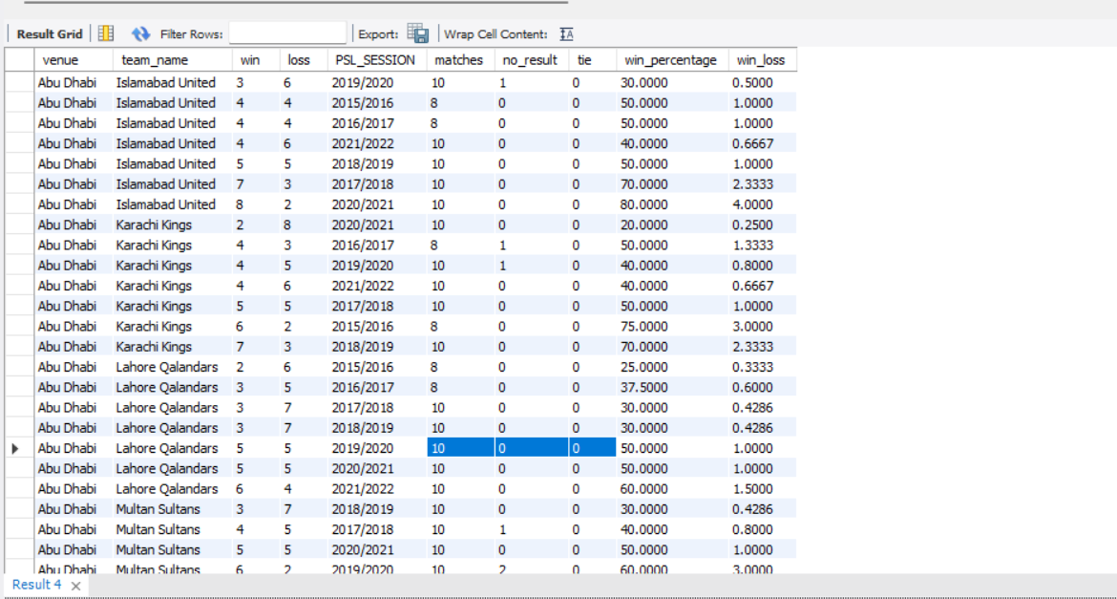

1. What is the average age of players participating in the PSL tournaments over the years?

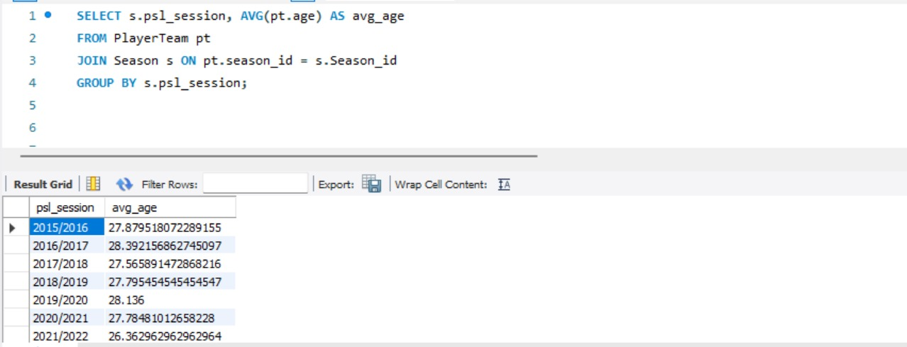

1. What is the overall distribution of player ages in the dataset?

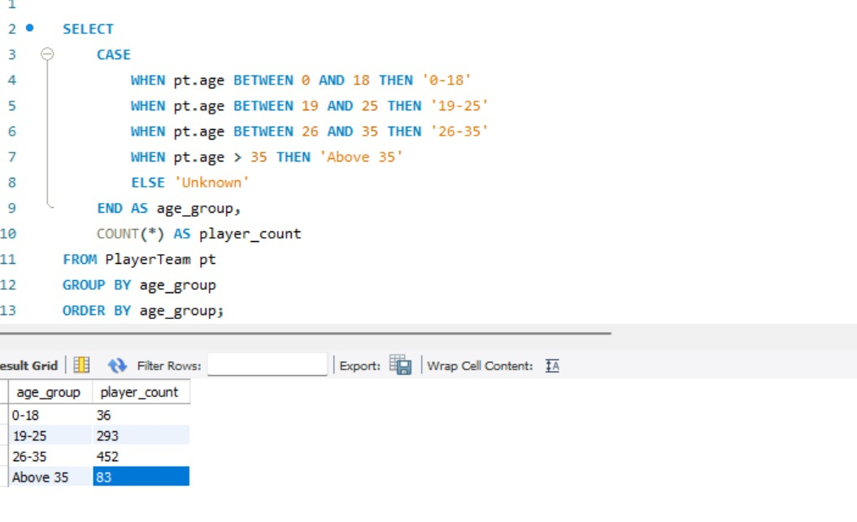

1. Youngest and Experienced Players Age Analysis season wise:

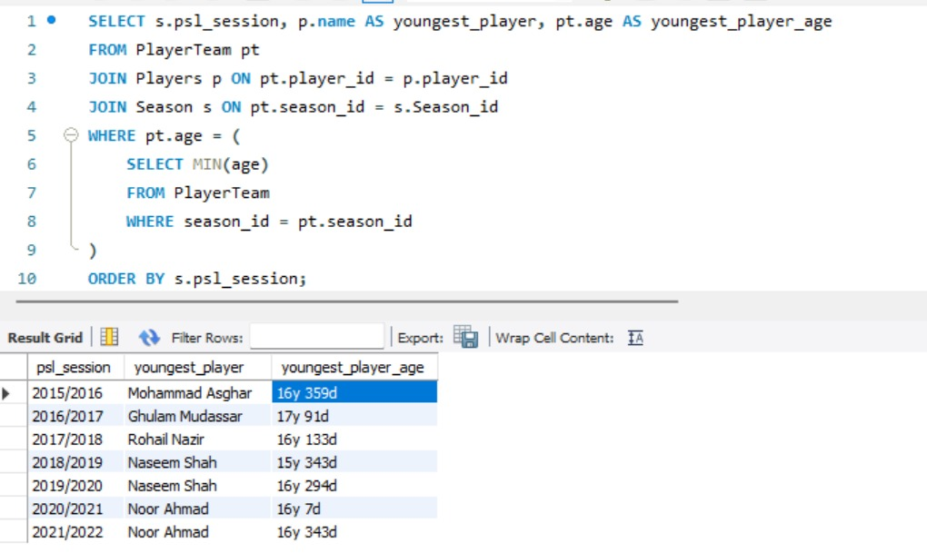

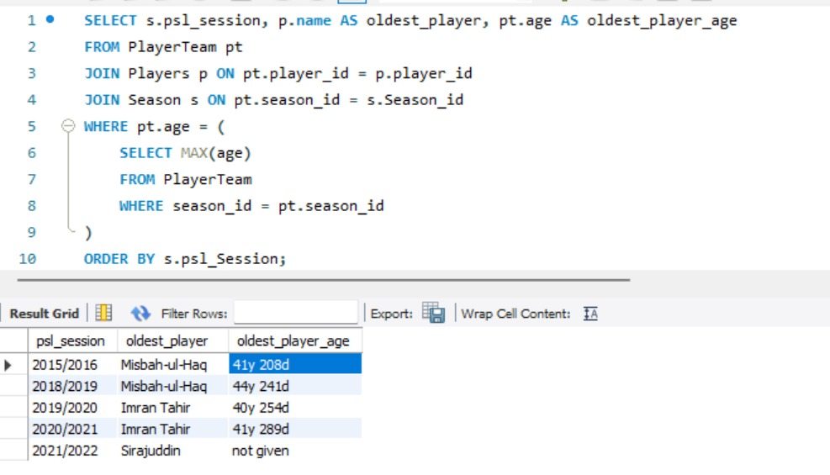

1. Comparing Batting Strike Rate and Bowling Economy Analysis:

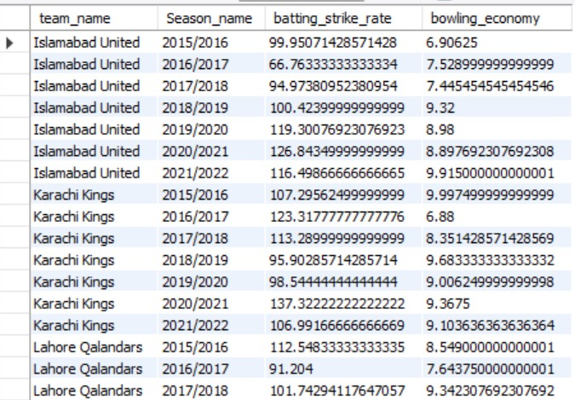

1. Analyze whether all-rounders tend to have more balanced performance in both batting and bowling compared to specialized players.

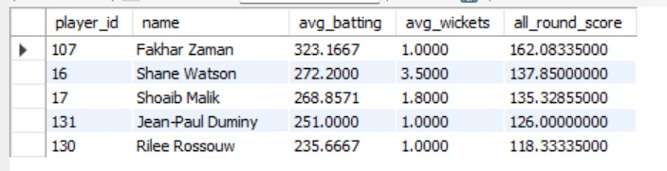

1. Analysis of Team Performances and Points Earned

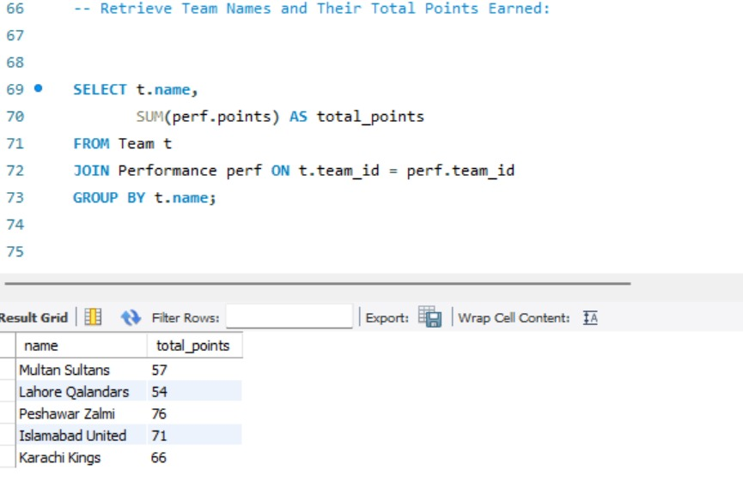

SQL QUERIES:

1. Query #1: Analyze the effects of various venues on team performance and season-long match results.

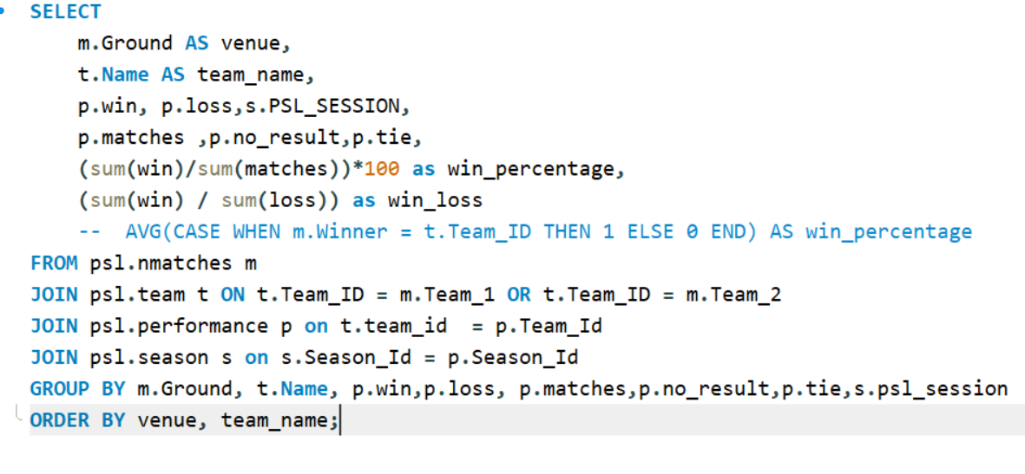

1. Query #2: Retrieve Player Names and Their Batting Averages: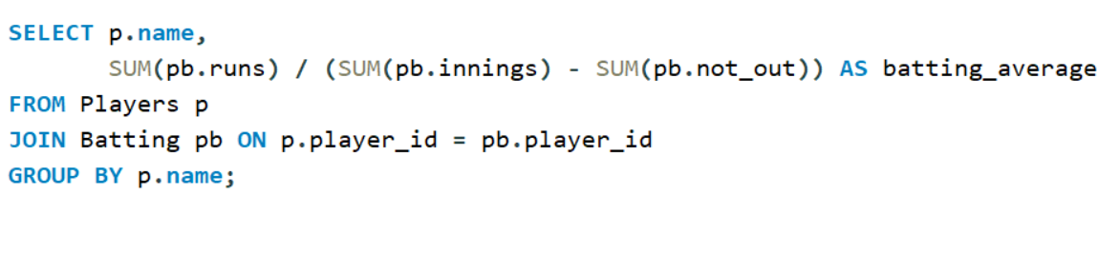
2. Query #3: Retrieve Team Names and Their Highest Margin of Victory:

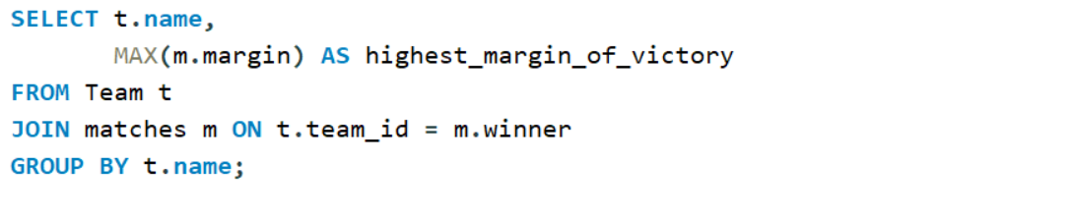

1. Query #4: Highest wicket taker per season

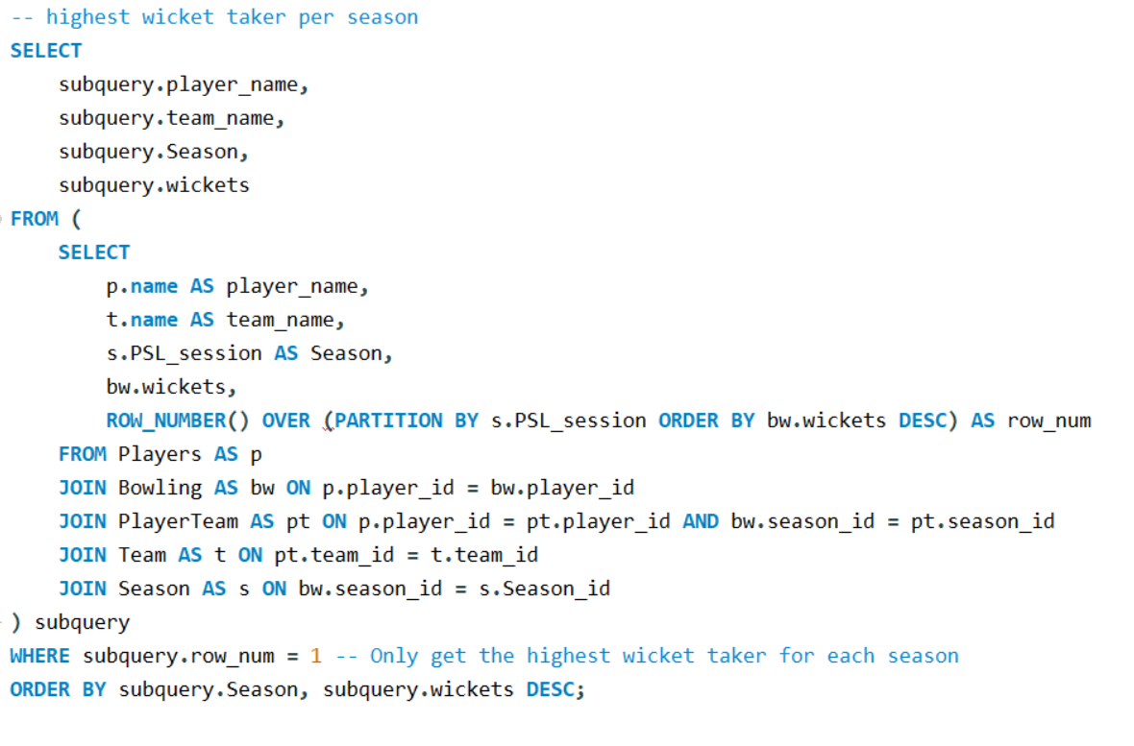

1. Query #5: Retrieve Team Names and Win Percentages and win-loss ratio

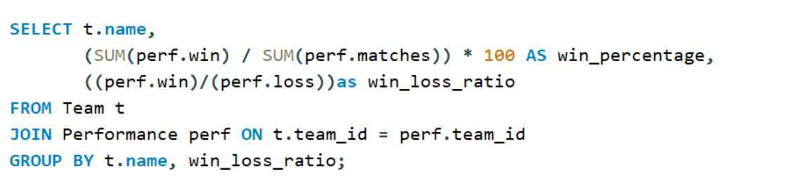

DASHBOARD VISUALS:

1. Economy rate of each bowler

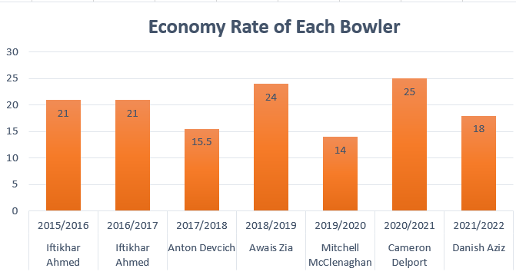

1. Maximum batting average of player

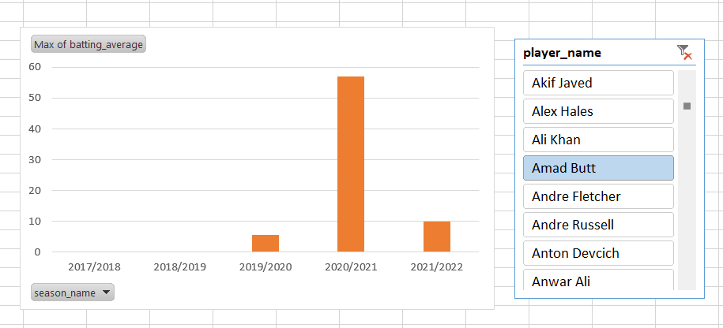

1. Maximum bowling strike rate of player

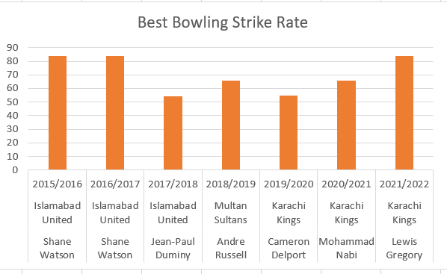

1. Highest run scorer in each season

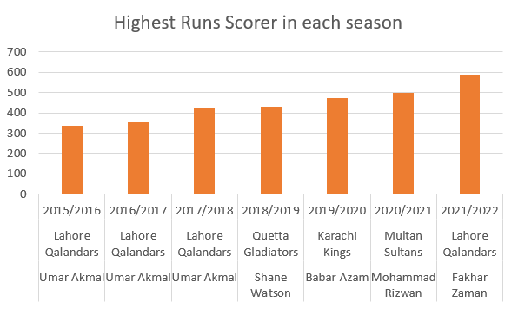

1. All-rounder players:

RECOMMENDATIONS:

* **Batsman's Struggle Analysis:** By analyzing a batsman's strike rate against different bowling styles, we can identify weaknesses and areas for improvement. This allows us to recommend targeted practice against specific bowlers to enhance the batsman's performance.
* **Bowler's Performance Evaluation:** Identifying suboptimal outcomes in a bowler's performance data suggests areas that need improvement. Focusing on physical conditioning and strength training can help the bowler unlock their full potential and improve their performance.
* **Player Combinations for Balance:** When assembling a cricket team, it's important to create a balanced combination of players with both batting and bowling strengths. This includes strategically allocating all-rounders, who can contribute effectively in both aspects of the game.
* **Adapting to Match Conditions:** Having a diverse team with a mix of skills allows the team to adapt to different match conditions. This flexibility enables the team to maximize favorable outcomes in various situations.

In summary, our approach involves data analysis to identify weaknesses and strengths, targeted training to address these aspects, and strategic team composition for adaptability. This comprehensive approach aims to enhance the team's overall performance and increase their chances of success in cricket matches.